“I don’t want anything to do with research, but I will talk to you”: Doing research in the context of disasters.

Margot Rawsthorne
University of Sydney

Abstract
On the 14th November, 2022 the small village of Eugowra in the Central West of New South Wales was hit by an ‘inland tsunami’ with widespread destruction and the loss of two lives. This small village was the place I was raised and many previous generations of my family had lived. Coincidentally, since 2015 I had been slowly drawn in the world of ‘disaster research’, with a specific focus on the experiences of communities navigating the terrains of disasters. I had heard stories and seen the destruction caused by floods, fires, storms and of course the Covid pandemic. But I had never imagined that my past and my present would collide in such a manner. Some 40% of the homes in Eugowra and all the active businesses were damaged by unprecedented (this type of language seems increasingly wrong) flooding. My initial engagement was as a volunteer, sorting material donations and listening to people still in shock. I wondered though right from the beginning how might my research knowledge of disasters be useful, although aware of its limitations in such a chaotic situation. Over time I realised that research knowledge could be useful in supporting community responses to disasters if it was offered with generosity, caution and humility. Navigating relationships and building trust repeatedly arose as requiring ongoing attention. In this article I aim to explore what there is to learn about disaster research when it becomes personal.
Keywords
Disasters; relationships; history; research
Introduction
This article seeks to contribute to recent challenges to orthodoxies in academic research through critical reflection on practice (see for example Rawlings, Flexner & Riley, 2021; Smith, 2021). It continues a questioning of what is knowledge, how is knowledge created, and how is knowledge deployed to enforce or disrupt power and privilege. It is written deliberately in the first person to acknowledge the embodied nature of knowledge (Leigh & Brown, 2021; Morrow & Kettle, 2023). The reflections in this paper have been strongly influenced by the experience of walking alongside people impacted by climate-related disasters. Listening and learning from these communities has demanded greater clarity about the value-base, purpose and use of research. Whilst the paper is shaped by a work with a large number of communities it adopts a case study approach focusing specially on the experience of ‘doing’ research in Eugowra.
Context
Eugowra is a small rural village home to less than 1,000 people. The village is built on the banks of Mandagery Creek, which feeds into the larger Lachlan River that winds its way through the New South Wales central west. The village and surrounds are scenic, with rolling hills and rich farm land (for cropping and herding). The steep, windy and narrow Mandagery Creek weaves through hilly terrain to the town’s centre, essentially splitting it in half east and west. In Wiradjuri (the local Aboriginal language) ‘mandagery’ means ‘chain of water holes’. The western side of town has always flooded but the higher eastern side has mostly seen very little water. The businesses and homes on the eastern side of the creek are accustomed to preparing for and cleaning up after water moves through. The geography of the creek means water raises quickly but also disperses quickly, if the Lachlan River is not also in flood. Locally people look up the creek to know what to expect in the next 10 to 12 hours. If the creek is out in Manildra or Molong the message goes out to lift furniture and sandbag shops. Throughout my childhood my aunt and uncle lived on the creek – people helped out before and after a flood went through. Floods were part of life.
The 2021 Australian Bureau of Statistics Census paints a picture of Eugowra that is similar to other small rural villages (Local Stats, 2023). Of the 914 people in the collector district, 22.7% are aged over 65 years of age. At the other end of the age spectrum only 5% of the population are aged under 5 years of age. Among those who worked there were more trades and labourers than professionals. 30% of the workforce worked with agriculture including a large dairy and beef feed lot. The residents are poor compared to the state average, with a median individual income of $448 per week (the NSW average is $813 per week) and a median household income of $774 per week (the NSW average is $1,829 per week). At the time of the Census over half of the homes (52.4%) were fully owned, 25.8% were being purchased by a home loan mortgage and 18.1% were rented. The median rent in Eugowra was $92 per week whilst the median mortgage repayment was $1,000 per month. The comparative affordability of housing has seen the population increase between census with low-income individuals and families settling. The village has seen a steady reduction in public facilities in recent decades like many rural villages across Australia. From two banks and a post office the village now has a Rural Transaction Centre providing postal, banking and social security (Centrelink, medicare, etc.) services. Students post-primary age now travel to larger regional schools. Two petrol stations and mechanics have closed with the only fuel in town now available from a depot. The local supermarket cannot compete with Woolworths and Aldi in neighbouring towns making it a choice of last resort. Health facilities are limited, with a sole part time GP and a Multi-Purpose Health Service (with 12 aged care beds). There is a nurse led 24 hour walk-in-service for people with minor injuries or illness. The closest large accident and emergency hospital is located over 1 hour away. Recreational facilities have also declined, with the 18-hole golf course sold to private interests for cropping and the tennis courts handed over for other uses.
Despite this picture of decline there have been strong efforts to revitalise the community led by the Eugowra Progess Association. The village hosts a significant harness racing event each year, with the second largest prize money in New South Wales. A new community pre-school has steadily increased its capacity over recent years with both local children and those working in neighbouring towns. New businesses had been attracted with a food truck particularly popular with locals and travellers. The village has also become known for public murals celebrating community life and history of the village. Mural artists from all over State support locals in the design and production of murals such as the one in Image 1 below. At the time of the 2022 floods the town had over 20 large scale public murals with an accompanying walking tour that was very popular to travellers.
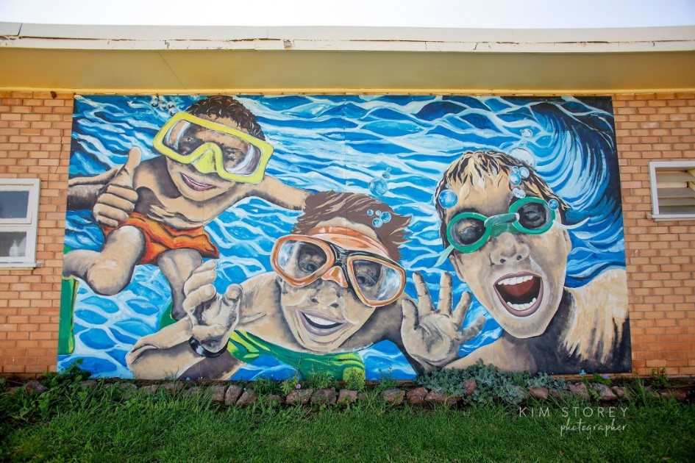
Image 1: Public mural at the local swimming pool: Photo courtesy Kim Storey (Australian Silo Art Trail, 2021)

My personal relationship with the village has been through many peaks and troughs. I left school at the age of 15 to work in the neighbouring town. My parents remained in the village so holidays and visits were reasonably regular after I moved to Sydney at the age of 18. Having the good fortune of access to free education I completed the HSC, a BA and a PhD over the following 20 years. I made my home in inner Sydney. I spent more than a decade working in various human service organisations, mostly in southwestern Sydney. In the early 2000’s I moved into academia and have worked at the University of Sydney since 2005. Some 40 years after I first left Eugowra my partner and I purchased 16 acres of land outside of the village. Some locals commented that I was ‘coming home’. So, despite not living in the community for many many years I was a familiar face and name in town, with many relatives still living there.
Disaster
The flood on the 14th November, 2022 destabilised what was known, what was understood as ‘normal’. The largest previous flood was recorded at 10.01m in 1950. Although not digitally confirmed, the 2022 flood topped 11.2 metres – half a metre higher than the village’s estimate for a one-in-5,000 year flood event (Gregory & Clifford, 2022). Whilst there were some warnings that a flood was imminent there was little warning of the scale. A particularly severe storm cell further upstream dumped rain into an already full catchment for 12 hours straight. The water from the storm surge that hit town around 9 am sending people on to their roofs in streets rarely impacted by flood previously. Over the next seven hours helicopters carried out 150 rescues from roof tops, including small children and the elderly, in hazardous conditions (Woodburn & Gregory, 2022). On my first visit about ten days after the flood I was confused by the large number of people with severely sunburnt faces. Later I came to realise that this was because of the many hours they had spent on roof tops waiting to be rescued unprotected from the sun. This is claimed to be the largest helicopter rescue of civilians in Australian history. The local emergency management services volunteers were small in number and overwhelmed. SES had mobilised resources to the neighbouring town of Canowindra the day before and they were now unable to return to Eugowra. RFS fire trucks on either side of the creek were moving from home-to-home rescuing people, particularly less mobile people stuck inside flooded homes.

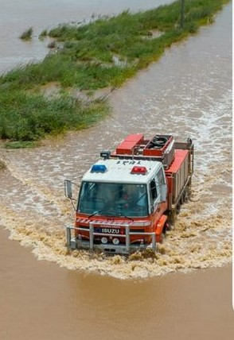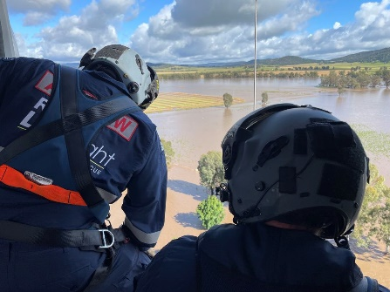
Image 2: Rescues (Photos courtesy Kim Story and Farmphix Photography)
Those that could and those that were rescued were relocated to the showground, the only large building on the eastern side of the creek unaffected by the flood. Whilst there was shelter there was no food, little water, no bedding and many people in shock. A small group of locals whose homes were outside the flood provided leadership and sought to manage the early response. They triaged people’s medical needs, co-ordinated food (people were arriving from outside of town with the contents of their freezers), created a list of those missing (by mid-morning this numbered over 20 people), and liaised with emergency services. Mobile communications were limited and at 6 pm all power was lost in the town. Whilst safe, people who had been rescued were facing a cold, hungry and uncomfortable night. Emergency response teams were quickly on the ground, but recovery services did not commence until the 21st November, some 7 days after the flood. The destruction of course was widespread. Image 3 below is of the street where I grew up. It shows two pre-fab homes that had been washed into the street by the storm surge from adjacent streets. These homes only came to a rest when they hit telephone poles. There are also footings from a home on Wilbe Street that was washed down the street and completely destroyed. Over the past 100 years flood water had impacted only once on this street, but never entered homes. A long-term neighbour recently recounted standing on his kitchen bench with his wife, his neighbour and her two small children. As the water continued to rise to their waists, he believed they would all drown as there was no longer any way out of the house.

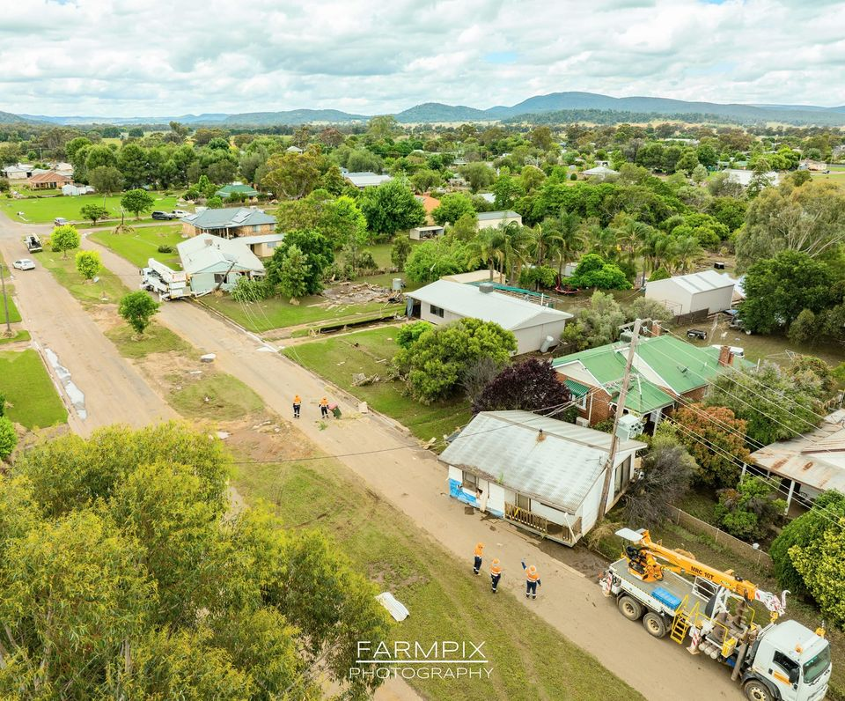
Image 3: Wilbe Street with houses washed 400 metres by the flood surge (Photo courtesy of Farmpix Photography).
In the following twelve months, over 700 people from Eugowra and surrounds registered and received support including access to grants, information and emotional support.

Research practice
Doing research in the context of disasters raises significant personal and ethical challenges. My historical connection to this place was embodied, not merely a research task understood within a positivist or objective epistemology. Ethical dilemmas abounded, created partly by the embodied nature of my participation. The political imperative of ‘doing good’ was likewise filtered through that embodiment. In the following section these challenges are discussed in order to explore what there is to learn about disaster research when it becomes personal.
Embodied research
In reflecting on my research practice in the context of the flood disaster in Eugowra I was struck by the embodied nature of the experience. By embodied I am referring to being ‘consciously self-aware' of bodies – mine and others – as well as my mind, thoughts, feelings, sensations and proprioceptive responses (Leigh & Brown, 2021). Nicole Brown explains:
In real terms, this might mean being aware of your breathing, the way that you are sitting, the tension in your body, any pain or discomfort or feelings of ease. It includes the thoughts and emotions that you have as well as an awareness of where these come from or what they might be connected to. (Brown, 2021)
In the early weeks the distress and shock of those affected by the flood was patently evident on people’s faces. They were dazed, hollowed out and vulnerable. I was conscious of not asking what ‘happened’ or intruding into people’s shock. Regardless, their stories just flooded from them, uncontrolled and at times incoherent. I surged with anger when overhearing emergency management volunteers ‘bragging’ about ‘bagging another big one’. Recently, on the anniversary of the disaster I found myself in tears revisiting the photos and the stories despite my distance from the event physically. My reaction was rooted in the places captured in the photos and the meaning those places had in my own story. In this way I think of my experience as historically embodied in childhood and family memories.
In trying to make sense of the experience I was attracted to Morrow & Kettle (2023) discussion of researchers immersing themselves to capture the ‘frontstage and backstage’ of what we are studying. In many research projects participants gatekeep access to the backstage, reflecting back to researchers what they believe is expected (Fleming, 2018; Dennis, 2014). Accessing the backstage of community practices is deepened by an understanding of what has been, of the origins of stories, and how power permeates what is possible on the frontstage. Moeran (cited in Morrow & Kettle, 2023) argue that crossing the boundaries from frontstage to backstage is valuable in building knowledge as
[Y]our [participants] may come to realize that you have learned the rules and know the difference between front and back stage games, and, as a result, they may stop pretending when in your presence and allow themselves to be seen as they are. (2009, p. 148)
The quote in the title of this article captures one of those moments. It was said to me by a community member who had been deeply involved in the response and recovery process in Eugowra as we walked to our cars after a 2-hour focus group. In the focus group she said little, allowing others to direct the conversation. As a researcher I wondered what did her silence mean, realising at that moment the toll the disaster had taken on her, and that she needed to assess my trustworthiness. Despite clearly describing myself as a researcher, with a university context, it was when I was seen as ‘not a researcher’ that I became trustworthy. Trust appears to be vital in qualitative research arising from participants experiences of being ‘understood’ without judgement (Dennis, 2014). In this interaction I was also positioned as an ‘insider’. Gair explores insider/outsider research as:
the degree to which a researcher is located either within or outside a group being researched, because of her or his common lived experience or status as a member of that group (2011, p. 137).
The notion of ‘degree’ here flags a shift away from the binary or dichotomy of ‘insider’ v ‘outside’. Certainly, my experience is that of being both inside and outside the disaster experience in Eugowra and that my research positionality was fluid (Fleming, 2018). When a resident shared their personal stories of the flood, I was outside the experience but when the same resident shared their frustration with the bureaucratic recovery system I was being called on as an insider. Rowlings's suggestion of being “alongside and with” (1999, p. 177) is much more insightful of the experience. Being alongside allowed a political and empathetic stance. Merton (cited in Fleming, 2018 p. 313) argues that:
Unlike the Insider, the Outsider has neither been socialized in the group nor has engaged in the run of experiences that makes up its life, and therefore cannot have the direct, intuitive sensitivity that […] makes empathetic understanding possible.
Empathy in qualitative research is often overlooked as being of ethical, political and practical importance (Gair, 2011). Research in disaster settings demands attention to how empathy is deployed for recruitment and access. Trust is damaged by false sincerity, friendship, or reciprocity but without empathic and emotional engagement our shared humanity is unlikely to be affirmed (Gair, 2011). In this way empathy facilitates a generosity of spirit, a willingness to be helpful and believing in the best of others.
Ethical issues
Too often when we think about ethical issues in research it is about compliance with institutional frameworks (Rawsthorne et al, 2023). Institutional ethics boards focus on informed consent, confidentiality, doing no harm, benefit, and justice (Rawsthorne et al, 2023). More recently in disaster research approvals processes have specifically focused on trauma informed research practice and how the research contributes to justice or just outcomes for participants. Insider research also has specific ethical challenges but commonly strategies imagine research practice as bounded within interviews (Fleming, 2018). These are important elements of research with people who have experienced disasters, but I found them to be of limited value when the disaster became personal. Waiting for coffee at the food truck people shared experiences freely after a simple ‘how are you doing?’ question. As they shared, I cautiously wondered ‘is this data?’, ‘what does consent mean here?’, ‘are they seeing me as an old classmate/neighbour or are they seeing me as a researcher with influence?’, ‘what can I do with this information?’. Clearly, I do not audio tape these interactions, nor do I ask for signed consent but they do contribute to the overall sense I’m making of the disaster. Here the political imperative to be of use was powerful as was an inclination towards generosity (Rawlings, Flexner & Riley, 2021). In my research I had information that would be of use to people as well as having connections to those who needed to be made aware of the issues being raised. For example, I learnt of the challenges being experienced by residents temporarily in caravans asking for funding for electrical goods like chest freezers and TVs. They felt they had to retell their story over and over again and the story had to be compelling to those making decisions. Mostly there was nothing new about the stories I was hearing but what struck me was the lack of contextual knowledge and flexibility in the disaster recovery system. Eugowra was an hour round trip was the closest large supermarket; caravan fridges are small and need to be re-stocked regularly. Chest freezers are essential when you cannot just go down the street for food. TVs, rather than being luxuries, likewise are essential for leisure, news, and entertainment. For those in caravans with small children the TV was also respite. When the issue was raised in recovery committee meetings, I was able to confirm that I too were hearing these stories and to support demands for more flexibility.
My relationships within the village allowed me access to ‘the backstage’ to see people ‘as they are’ but would they share these experiences with me in the same way if I was a ‘researcher?’. As a researcher, particularly one who routinely uses action research methodology, the question of what constitutes ‘data’ is not new. In the context of trauma though the ethical aspects of this is heightened (Dennis, 2014). Beneficence, doing good and community benefit created a sense of inadequacy and guilt. I was aware of time passing with little or no contact with the recovery committee, who I had become obligated to in a much stronger way than previous research. My knowledge of disasters though did provide some comfort – I understood that this was a long haul, and if my relationships were deep enough, I would be able to reconnect in the future.
Research as recovery
Many qualitative researchers have experienced a sense of gratitude from interview participants for being ‘listened to’ or as researchers some time describe this as ‘giving voice’ (Gair, 2011; Dennis, 2014). Whilst there was an element of this when disasters become personal there is also something else going on. As an experienced researcher I was able to bring knowledge about the emergency management system, self-organising, community development, and the broader policy context. In this way, generously sharing knowledge from research became part of the recovery process. As an example, I was aware of a community-led conference being organised in the Blue Mountains that I hoped would provide support for those community members leading the recovery. I attended the conference with some community members who had the opportunity to learn from other community members in not only the Blue Mountains but Lismore and Mallacoota. The lessons of others were often referred to in discussions within Eugowra. Through linking people new language, such as social infrastructure and social capital (Aldrich & Meyer, 2015), was adapted by members of the recovery committee to navigate the formal recovery system.
Research processes are also potentially useful in recovery. Collectively with members of the recovery committee we began the process of documenting (though a Ripple Effects Map) the hours before and after the flood as well as the successes and challenges over the first 12 months. This process seemed affirming to a group of people who had no previous experience of shaping a community wide recovery from a catastrophic event. The process also identified structural blockages (the New South Wales election for example) that helped make sense of periods of frustration. Capturing and sharing the experiences of people acting in disasters is regenerative not only of those people but also the broader community. Offered with generosity research can play a part in reknitting fractured communities (Howard & Rawsthorne, 2019).
Doing research in the context of disasters however needs to be approached cautiously and with reflexivity. Researchers not only need to be aware of their professional power but also to offer it with humility. Communities following disasters are highly vulnerable and extra care is required by those external to the community, including researchers. We need to be aware of the reification of certain forms of knowledge (usually described as expertise) at the exclusion of others, particularly that arising from lived experience. For me humility meant sharing knowledge in the everyday, in small ways, to make a difference. Humility is also about not over promising – research whilst of some use did not help people rebuild or make decisions about their futures. Trying to work out how best my skills, knowledge and experiences could be ‘of use’ to those I was alongside and with is an ongoing challenge. It requires agility in positioning myself across the inside and outside boundaries of the disaster experience. On the 12-month anniversary, for example, I understood it was not my place to be present in the community. This was a time when boundaries for those ‘inside’ the event where protective and nurturing of those with a shared experience of the 14th November. Here I drew on my community development theories and practice but also the work of Smith (2021) who challenges researchers to be critically aware of how we position ourselves and the importance of humility.
Rethinking community
The experience of being alongside and with people affected by the flood also raised questions about the notion of community, a concept that has captured my imagination and my intellect for the past few decades. Shared values are assumed in the community development (and other) scholarship as an essential catalyst for collective action. Mine and many others response to the flood event in Eugowra was an enactment of community. Hundreds of people responded to the event, despite large distances and possibly significant differences in values. Ex-residents, some of whom had not lived in the community for decades, organised working bees of university students, mobilised electrician and other trades, raised money within their workplaces, spent hours shifting through damaged museum exhibits, documented stories through video and photography. Others, like myself, offered resources and knowledge that may be useful for the community in recovery. In my case this was despite strong political and philosophical differences, not ‘shared values’. Exemplifying this, in the Referendum the electorate of Calare (of which Eugowra is a part) had over 70% “No” votes. The electorate in which I have lived for 30 years (Grayndler) had one of the strongest “Yes” votes (Guardian, 2023). In the context of significant value differences, how do we make sense of the drive to act collectively? In this situation is seems possible that it reflects a historical belonging to place, to the landscape of our childhood, extending how we think theoretically about the notion of community. This extended notion of community may have important implications for future emergency management responses to increasing climate-change related disasters. For small communities such as Eugowra embracing and mobilising this extended community brings additional skills and resources to the recovery process. Importantly this extended community is also likely to be less affected by the event and hence more able to respond. There is a risk, however, that these additional skills and resources crowd out or replace localised action. As such the local community needs to maintain control of how, when and why these additional skills and resources are mobilised.
Conclusion
Qualitative researchers often seek access to the backstages of people's lives, to understand the meaning people make of their emotional, social, political lives. For other researchers working with those impacted by disasters paying attention to ethics in practice rather than ethical approval is key. This includes being cautious or considered about how, when, and why you are collecting data. Navigating this complex ethical terrain requires reflexivity as institutional frameworks provide limited support. At its foundation, this is about being aware of power and how it infuses your research practice and the relationships you establish. If research is to become useful in recovery, it is also about offering knowledge with humility. Rather than framing your research as either inside or outside being useful as a researcher in disasters is about walking alongside. Again, reflexivity here is important in understanding how belonging shapes research practice in both positive and negative ways. Finally, as climate-change related disasters increase research that does not seek to transform practices, policies or community is not only indulgent it is harmful. It seems unlikely that humans will now prevent catastrophic climate-change and as such we must ensure those affected have access to the very best scientific, technological, and social knowledge to reduce harm. This is the humane, ethical, and political imperative that must inform the work of disaster researchers. Our approach should be based on generosity, caution, and humility.
When the focus of my research interest ‘became personal’ I was challenged in surprising ways. I was assaulted by images through TV and social media despite understanding the familiar media trope (something I think of as ‘disaster porn’). The word ‘assaulted’ is used here deliberately to capture the embodied experience of seeing and hearing these stories. This was followed by a sense of inadequacy – how could I be useful? - in such a chaotic and catastrophic situation. This is a question I continue to ask.

References
ABS (2022) Income and work: Census. https://www.abs.gov.au/statistics/labour/earnings-and-working-conditions/income-and-work-census/latest-release
Aldrich, D. P., & Meyer, M. A. (2015). Social Capital and Community Resilience. The American Behavioral Scientist, 59(2), 254–269. https://doi.org/10.1177/0002764214550299
Australian Silo Art Trail (2021) Eugowra, https://www.australiansiloarttrail.com/eugowra-street-art-town
Brown, N. (2021) Embodied Inquiry as a Research Method, Methodspace, SAGE, https://www.methodspace.com/blog/embodied-inquiry-as-a-research-method
Dennis, B. K. (2014). Understanding Participant Experiences: Reflections of a Novice Research Participant. International Journal of Qualitative Methods, 13(1), 395–410. https://doi.org/10.1177/160940691401300121
Gair, S. (2012). Feeling Their Stories: Contemplating Empathy, Insider/Outsider Positionings, and Enriching Qualitative Research. Qualitative Health Research, 22(1), 134–143. https://doi.org/10.1177/1049732311420580
Gregory, X. & Clifford, J. (2022) Wiped out and waiting for answers. ABC Online, Published 6 December, 2022. https://www.abc.net.au/news/2022-12-06/how-an-extreme-flash-flood-destroyed-eugowra/101711140
Guardian (2023). Voice referendum live results, https://www.theguardian.com/australia-news/ng-interactive/2023/oct/17/live-voice-referendum-results-aec-2023-poll-tracker-by-electorate-state-australia-yes-no-vote-polls-percentage-the-australian-indigenous-voice-to-parliament-who-won-result-winner-map-counts
Farmpix (2023). Farmpix Photography, https://www.farmpix.com.au/
Fleming, J. (2018). Recognizing and resolving the challenges of being an insider researcher in work-integrated learning. International Journal of Work-Integrated Learning, 19(3), 311-320.
Howard, A., & Rawsthorne, M. (2019). Everyday community practice. Allen & Unwin.
Leigh, J. & Brown, N. (2021). Embodied Inquiry: Research Methods, Bloomsbury.
Local Stats (2023). 2011 Census: Eugowra. https://localstats.com.au/demographics/nsw/regional-nsw/central-tablelands/eugowra
Morrow, F., & Kettle, M. (2023). Putting the auto in ethnography: The embodied process of reflexivity on positionality. Qualitative Social Work : QSW : Research and Practice. https://doi.org/10.1177/14733250231196430
Rawlings, V., Flexner, J. L., & Riley, L. (Eds.). (2021). Community-Led Research: Walking New Pathways Together. Sydney University Press. http://www.jstor.org/stable/j.ctv1rcf2jj
Rawsthorne, M., Tseris, E., Howard, A., Terare, M. & Sharma, A. (2023). Using social research for social justice : an introduction for social work and human services. Routledge. https://doi.org/10.4324/9781003243793
Rowling, L. (1999). Being in, being out, being with: Affect and the role of the qualitative researcher in loss and grief research. Mortality (Abingdon, England), 4(2), 167–181. https://doi.org/10.1080/713685968
Smith, L. T. (2021). Decolonizing Methodologies: Research and Indigenous Peoples (Third edition.). Zed Books.
Woodburn, J. & Gregory, X. (2022) Helicopter rescue bills issues to Eugowra residents after deadly flood to be waived, ABC News, https://www.abc.net.au/news/2022-12-14/eugowra-flood-victims-sent-bills-for-helicopter-rescues/101770596

